# PCS-RASP UPDATE

4/4/2022

PCS Raspberry Simulation Example Illustration

1. This image show
2. Raspberry python application subscribe to MQTT topic and listen for incoming data.
3. The actual reading from raspberry is range from 248 to 255.
   * # Tower (3 type)
   * # Address 0x01 = 248 All on
   * # Address 0x01 = 249 Orange + Green
   * # Address 0x01 = 250 Red + Green
   * # Address 0x01 = 251 Green
   * # Address 0x01 = 252 Red + Orange
   * # Address 0x01 = 253 Orange
   * # Address 0x01 = 254 Red
   * # Address 0x01 = 255 all off
4. Let use 255 and 248 as example, 255 mean 3 lights all off , 248 mean 3 lights all on.
5. Mock data for 3 light tower type, this show first 10 tuple of 0.1 seconds reading is value 2, another 10 tuple of 0.1 second reading is value 1.
   1. {'data': [(2, 2, 2), (2, 2, 2), (2, 2, 2), (2, 2, 2), (2, 2, 2), (2, 2, 2), (2, 2, 2), (2, 2, 2), (2, 2, 2), (2, 2, 2), (1, 1, 1), (1, 1, 1), (1, 1, 1), (1, 1, 1), (1, 1, 1), (1, 1, 1), (1, 1, 1), (1, 1, 1), (1, 1, 1), (1, 1, 1)],

'address': ('Red', 'Amber', 'Green')}

* 1. Value to Light Event Table

|  |  |
| --- | --- |
| Value | State |
| 1 | Off |
| 2 | On |

* 1. For 3 light tower type , each tuple index (2, 2, 2) represent ('Red', 'Amber', 'Green')
  2. For entire data with 20 tuples , represent 20 x 0.1 seconds which contribute to duration of 2 seconds.

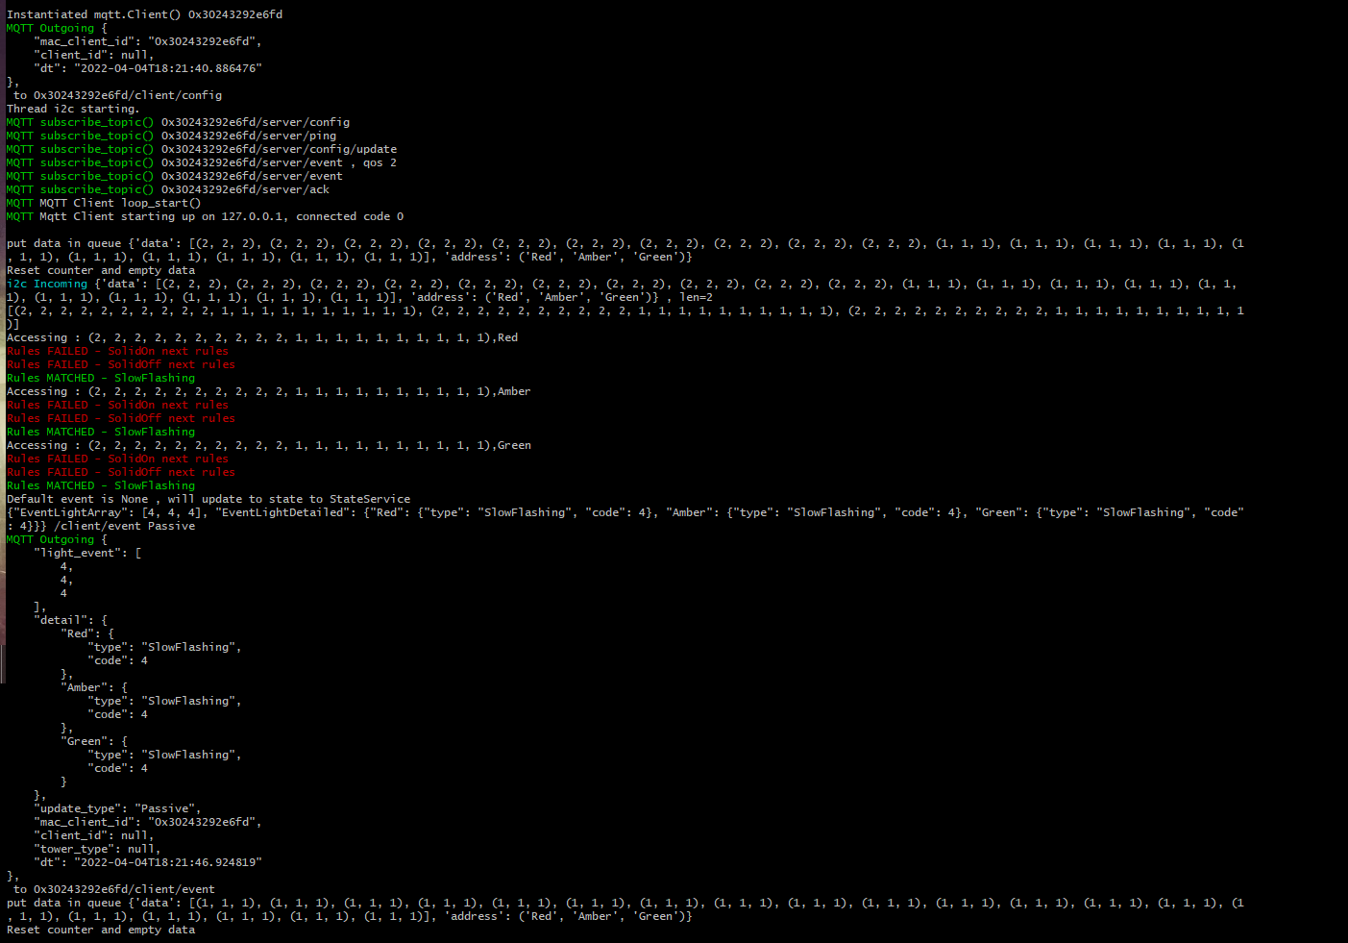

1. This image show rasp application detect event light change from Slow Flash to Solid On

